Course Title: Social Immersive Learning
Course Code: 24UC0022
Name: L.Ishitha
Roll No: 2420030041
Section: 10

Title of the Event:
International Conference on “Mathematical Modeling in Computational Intelligence and GenAI (Math-CIGAI) – 2025”

Organized by:
Department of Computer Science and Engineering (AIML), KLH University – Bachupally Campus
(In association with Springer)

Dates:
July 17, 2025 | 9:00 AM – 5:00 PM

Event Summary:
KLH University’s Bachupally Campus hosted the prestigious International Conference on “Mathematical Modeling in Computational Intelligence and GenAI (Math-CIGAI) – 2025.” This high-level academic event, organized in association with Springer, focused on the intersection of advanced mathematics and the rapidly evolving field of Artificial Intelligence.
The conference provided an immersive platform for researchers, faculty, and students to explore state-of-the-art developments in using mathematical models to enhance the theoretical and performance aspects of Computational Intelligence and Generative AI systems. Sessions included keynote speeches, research paper presentations, and panel discussions highlighting the mathematical mechanisms behind neural networks and creative AI algorithms. The event promoted valuable academic exchange and enriched participants’ understanding of interdisciplinary AI research.

Key Highlights:
- Expert keynote talks from international researchers on AI and computational modeling.
- Technical sessions covering innovations in Generative AI, Neural Networks, and Predictive Systems.
- Research paper presentations published under Springer’s proceedings.
- Opportunities for students to interact with global AI experts and discuss emerging trends in GenAI.
- Exposure to the latest advancements in integrating mathematics with machine learning for robust AI design.

My Participation:
As a participant, I attended several sessions of the Math-CIGAI 2025 conference, gaining deep insights into how mathematical modeling contributes to the foundation and advancement of AI technologies. The discussions on neural architectures, algorithmic design, and generative systems helped me understand the theoretical underpinnings of Artificial Intelligence beyond coding and implementation. This experience inspired me to explore AI research more deeply and appreciate the essential role of mathematics in building reliable and explainable intelligent systems.

Event Photographs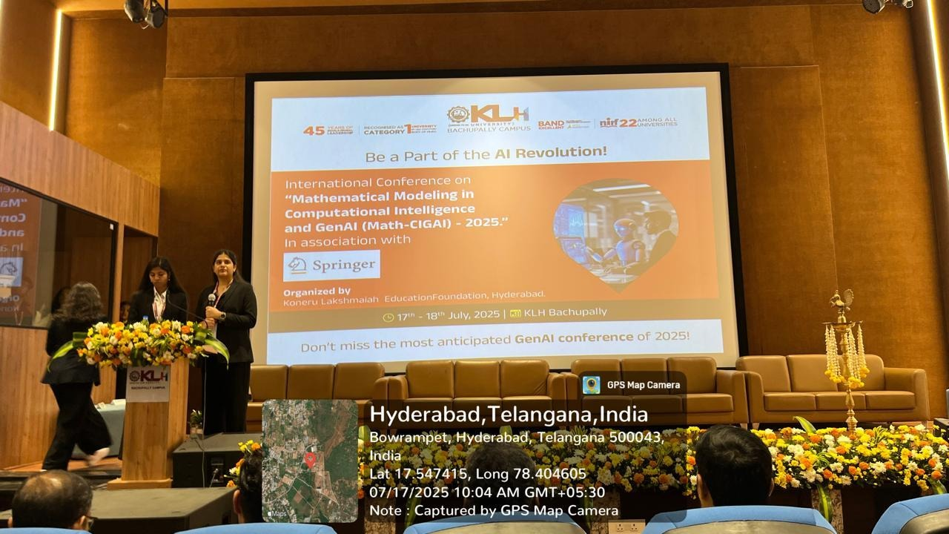:

Conclusion:
The Math-CIGAI 2025 conference was an excellent academic experience that broadened my perspective on the synergy between mathematics and AI. It motivated me to pursue analytical approaches while studying modern AI concepts and provided an excellent opportunity to witness cutting-edge research from global scholars.

Acknowledgment:
Special thanks to KLH University and the Department of Computer Science and Engineering (AIML) for organizing this international conference and providing students a platform to engage with world-class researchers and scholars.

